

*Draft*

**VACCINE LOGISTICS**

**MANAGEMENT INFORMATION SYSTEM**

User Manual (Campaigns)

September 2014



**Table of Contents**

[Revision History 7](#_Toc402260113)

[List of Acronyms 8](#_Toc402260114)

[Overview 11](#_Toc402260115)

[Background 11](#_Toc402260116)

[Overview of Web-based LMIS 13](#_Toc402260117)

[**Vaccine Logistics Management Information System (vLMIS)** 15](#_Toc402260118)

[**vLMIS Features** 17](#_Toc402260119)

[**Assumptions** 18](#_Toc402260120)

[**System Requirements** 18](#_Toc402260121)

[**Browser Support** 18](#_Toc402260122)

[Users & User Roles 19](#_Toc402260123)

[**Anonymous/Guest User** 19](#_Toc402260124)

[**Authenticated Users** 20](#_Toc402260125)

[**EPI User – National** 20](#_Toc402260126)

[**EPI User – Provincial** 21](#_Toc402260127)

[**EPI User – District** 22](#_Toc402260128)

[**EPI User - Tehsil** 24](#_Toc402260129)

[**EPI User - UC** 25](#_Toc402260130)

[**Policy User (National, Provincial and District)** 26](#_Toc402260131)

[**Campaign User (National)** 26](#_Toc402260132)

[**Campaign User (Provincial)** 27](#_Toc402260133)

[**Campaign User (District)** 27](#_Toc402260134)

[**CCEM Operators (National, Provincial, District)** 28](#_Toc402260135)

[**Geographical Areas** 29](#_Toc402260136)

[Step-by-Step 30](#_Toc402260137)

[vLMIS Homepage 31](#_Toc402260138)

[**Homepage Menu** 32](#_Toc402260139)

[**Contact Us Tab** 32](#_Toc402260140)

[**Frequently Asked Questions Tab** 32](#_Toc402260141)

[**Changing Your Password** 34](#_Toc402260142)

[**Forgot Password** 35](#_Toc402260143)

[**Logging Out** 36](#_Toc402260144)

[Dashboards 37](#_Toc402260145)

[Overview 37](#_Toc402260146)

[**Campaign User** 38](#_Toc402260147)

[**National Level Dashboard** 39](#_Toc402260148)

[**Campaign Management** 40](#_Toc402260149)

[**Provincial Level Dashboard** 46](#_Toc402260150)

[**Campaign Management** 47](#_Toc402260151)

[**District Level Dashboard** 53](#_Toc402260152)

[**Campaign Management** 54](#_Toc402260153)

[Campaigns 59](#_Toc402260154)

[Campaigns 59](#_Toc402260155)

[**Campaign Stock and Reporting Cycle** 60](#_Toc402260156)

[**Campaign Enhancements** 61](#_Toc402260157)

[Campaign National User 62](#_Toc402260158)

[**Campaign Options** 63](#_Toc402260159)

[**Add Campaign** 64](#_Toc402260160)

[**Data Entry History** 65](#_Toc402260161)

[**Search Campaigns** 67](#_Toc402260162)

[**Campaigns Target** 69](#_Toc402260163)

[**Lot Quality Assurance Sampling (LQAS) Data Entry** 71](#_Toc402260164)

[**Campaign Reports** 74](#_Toc402260165)

[**Campaigns Summary (Coverage)** 75](#_Toc402260166)

[**Campaigns Detail (Coverage)** 76](#_Toc402260167)

[**Catch-Up** 77](#_Toc402260168)

[Campaign Provincial User 78](#_Toc402260169)

[**Campaign Options** 80](#_Toc402260170)

[**Add Campaign** 81](#_Toc402260171)

[**Data Entry History** 82](#_Toc402260172)

[**Search Campaigns** 84](#_Toc402260173)

[**Campaigns Target** 86](#_Toc402260174)

[**Lot Quality Assurance Sampling (LQAS) Data Entry** 88](#_Toc402260175)

[**Campaign Reports** 91](#_Toc402260176)

[**Campaigns Summary (Coverage)** 92](#_Toc402260177)

[**Campaigns Detail (Coverage)** 93](#_Toc402260178)

[**Catch-Up** 94](#_Toc402260179)

[**Lot Quality Assurance Sampling (LQAS) Report** 95](#_Toc402260180)

[Campaign District User 96](#_Toc402260181)

[**Campaign Options** 98](#_Toc402260182)

[**New Data Entry** 99](#_Toc402260183)

[**Data Entry History** 100](#_Toc402260184)

[**Campaign Readiness** 102](#_Toc402260185)

[**Campaign Readiness UC** 105](#_Toc402260186)

[**Reported UCs** 108](#_Toc402260187)

[**Campaign Reports** 109](#_Toc402260188)

[**Campaigns Summary (Coverage)** 110](#_Toc402260189)

[**Campaigns Detail (Coverage)** 111](#_Toc402260190)

[**Catch-Up** 112](#_Toc402260191)

# Revision History

|  |  |  |  |
| --- | --- | --- | --- |
| **Name** | **Date** | **Reason For Changes** | **Version** |
| Pakistan Field Office | 30 August 2014 | Addition of campaign module | 1.0 |
| Pakistan Field Office | 15 September 2014 | Addition to Dashboards | 1.1 |

# List of Acronyms

|  |  |
| --- | --- |
| AJK | Azad Jammu & Kashmir |
| AMC | Average Monthly Consumption |
| BCG | Bacillus Calmette–Guérin Vaccine |
| BHU | Basic Health Unit |
| bOPV | Bivalent oral polio vaccine |
| CCEM | Cold Chain Equipment Manager |
| DHCSO | District Health Communication Support Officer |
| DHQ | District Head Quarter Hospital |
| DMS | Deputy Medical Superintendent |
| DSV | District Superintendent Vaccination |
| EDO | Executive District Officer |
| EPI | Expanded Program on Immunization |
| FATA | Federally Administered Tribal Areas |
| GAVI | Global Alliance for Vaccines and Immunization |
| GOP | Government of Pakistan |
| HF | Health Facility |
| ICT | Information Communications Technologies |
| IM | Inventory Management |
| IT | Information Technology |
| JSI | John Snow, Inc. |
| KP | Khyber Pakhtunkhwa |
| LMIS | Logistics Management Information System |
| LQAS | Lot Quality Assurance Sampling |
| MIS | Management Information System |
| MIPC | Ministry of Inter Provincial Coordination |
| MNHRC | Ministry of National Health Services, Regulation and Coordination |
| NID | National Immunization Days |
| OPV | Oral Polio Vaccine |
| PEI | Polio Eradication Initiative |
| PPHI | Peoples Primary Healthcare Initiative |
| SDP | Service Delivery Point |
| SIADs | Short Interval Additional Dose Strategy |
| SIAs | Supplementary Immunization Activities |
| SOP | Standard Operating Procedure |
| Syr. | Syringe |
| THO | Taluka Health Officer |
| THQ | Tehsil Head Quarter Hospital |
| tOPV | Trivalent oral polio vaccine |
| TSI | Tehsil Sanitary Inspector |
| UC | Union Council |
| UNICEF | United Nations Children's Fund |
| UPEC | Union Council Polio Eradication Committee |
| USAID | United States Agency for International Development |
| WHO | World Health Organization |

|  |  |
| --- | --- |
| Overview | **1** |
| With Vaccine Logistics Management Information System | |

The *Vaccine Logistics Management Information System User Guide* provides step-by-step instructions that help you get started with Vaccine Logistics Management Information System (vLMIS) functions and features and provides guidelines on managing relevant Vaccines Logistics data using the Vaccine Logistics Management Information System accounts.

This guide is organized according to the logical flow of Vaccine Logistics Management Information System features and describes tasks in the same order you can use while working with the product.

|  |  |
| --- | --- |
| *C:\Users\isbah.zulfiqar\Desktop\1382615592_file_edit.png* | Before You Begin...  It is recommended to have a working internet connection for web-access to the application in order to review the product side-by-side when reading this manual. |

# Background

In July 2011, Pakistan’s first web-based Logistics Management Information System (web-LMIS) for contraceptive products was launched, which is currently in use in all 143 districts. Following the success of the Logistics Management Information System for Contraceptives, the design of a   
web-based Tuberculosis Drug Management Information System (TBDMIS) was rolled-out in   
March, 2013 and now, Vaccine Logistics Management Information System has also been incorporated into the current Logistics Management Information System in 54 priority districts in Pakistan, thus making the web-based Pakistan Logistics Management Information System as one automated logistics management information system for all health commodities, i.e., Contraceptives, Tuberculosis and Vaccines.

The Vaccine Logistics Management Information System (vLMIS) is designed to replace the current manual Vaccine Logistics Record keeping system and therefore considers the current system’s strengths and challenges.

Among the strengths in the current vaccine logistics data is that key data items are collected, such as consumption, stock balance, and storage capacity. Some logistics-related key performance indicators have been defined and are tracked. Data is collected routinely and there is a defined process flow for reporting up the system. There are established forms and spreadsheets used to collect data, and a vaccine stock management software solution used at the National EPI Store. There is a culture of compiling and analyzing data for logistics decision making. The data on existing cold chain equipment (age, type, capacity, operability) in the national cold chain inventory as well as facility profile data has also been collected to help identify gaps in the cold chain storage capacity and functionality that need to be addressed.

However, there are significant challenges in the collection, use and management of vaccine logistics data. Routine reporting of logistics data is impeded by poor accuracy and timeliness of the reports and inadequate supervision and feedback on reporting. Wastage (due to open vial) data are under-reported and poorly tracked. Resupply is calculated based on demographic based targets (using population figures that are outdated) rather than consumption data, and stock balance is not always factored into resupply decisions. Because data is not available in real-time electronic form to all stakeholders, there is very limited visibility in the pipeline below the national level.

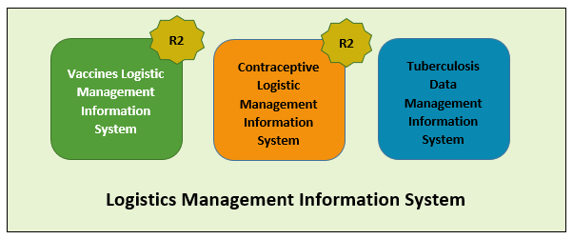

# Overview of Web-based LMIS

Pakistan Web-based LMIS provides transparency to all stakeholders based on user rights, is easy to use, and integrates both routine and special immunization campaign vaccine logistics data. Standardized reporting forms and Data triangulation is implemented to validate data and improve visibility in wastage rates.

Resupply quantities for routine EPI are calculated based on average monthly consumption and stock balances, and wastage rates are calculated automatically. The use of stock balance, consumption and issued data, losses and adjustments are also collected.

New routine reporting forms are aquatically printed using vLMIS inventory management module in order to collect data from service delivery points, along with vaccine logistics standard operating procedures (SOPs) for each level of the supply chain.

The Vaccine Logistics Management Information System contains the following features:

1. A module for Vaccine reporting in the centralized web-accessible data repository of LMIS to report data from data providers. Data Providers can perform monthly data entry. This also includes being able to generate reports for themselves.
2. The data provided by different geographical levels tracks vaccines in different data entry forms. The Stock Issue and Receive Data, (National, Provincial, Divisional, District, Tehsil) users will enter vaccines logistics data with batch and expiry information, while Monthly Consumption data (Tehsil and Union Council level) users will report data without batch. Wastage will be calculated automatically with the help of consumed and unused vial information.
3. The cold-chain inventory and use is tracked in vLMIS. This module is capable of entering new cold chain assets as well as its current operational status. Each month, along with other logistics data, users will update the operational status of their cold chain assets.
4. The Administrator will manage vLMIS and create all of the necessary data in order to assist users to continue to provide and review logistics data.
5. Data Reviewers can access vLMIS using the ‘guest’ user account and get reports about the country’s provinces and districts to help them in logistical decision-making regarding supply chain management in their assigned districts.

## **Vaccine Logistics Management Information System (vLMIS)**

The web-based Vaccine Logistics Management Information System has been designed to help plan and manage the immunization resources and ensure that vaccines are always available to meet demand at the right time, to the right place, at the right cost, in the right condition of the right product in the right amount – No matter where they live.

|  |
| --- |
| http://www.mchip.net/sites/default/files/India%20mom%20and%20boy%20saveJPG_0.JPG**Millions of people are alive today because of immunization programs** from diseases such as diarrhea, pneumonia, polio, measles, tetanus, and other life-threatening illnesses. The current immunization programs save more than **2.5 million lives each year**; however, **24 million children still do not get** the complete routine immunizations scheduled for their first year of life, because of weak health systems and difficulties with delivering vaccines to remote locations on time. |

The web-based Vaccine Logistics Management Information System (vLMIS) is an extension of the Logistics Management Information System (LMIS) and is designed to replace the current paper-based logistics information system that is being used for managing the vaccine distribution and logistics.

The Vaccine Logistics Management Information System introduces systematic vaccine product management and create sustainable dependencies among different vaccine procurement procedures and geographical level operations.

The web-based Vaccine Logistics Management Information System (vLMIS) is easy to use and contextualized to fit local stakeholder’s structure and the devolution of health and population programs to provincial governments. The system brings in district and EPI-level reporting by aggregating facility-level data through paper-based reports. With a unified system for reporting and requisitioning, the vLMIS system is able to integrate information from all levels and sectors. The web-based vLMIS can be accessed at <http://lmis.gov.pk>.

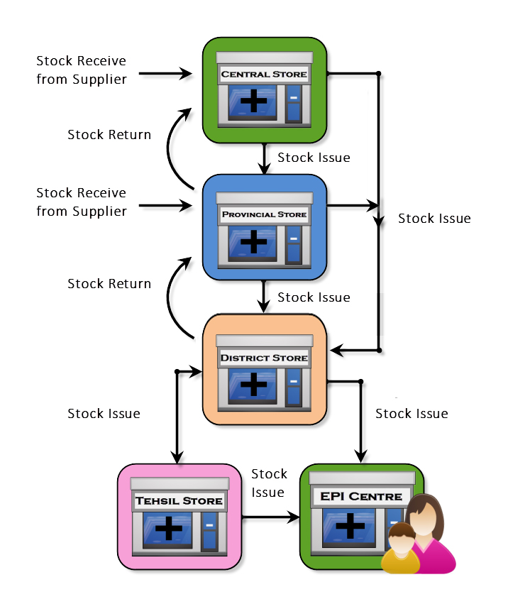

**The Vaccine Supply Chain**

## **vLMIS Features**

Vaccine Logistics Management Information System provides the following functions and features:

|  |  |
| --- | --- |
| Role-Based Access for Users  Users are authenticated based on their geographical levels and the roles that are associated with them. | Inventory Management  Stock Issued, Received, and adjustments are recorded on transaction basis in vLMIS by the EPI Store Users. |
| Automated Stock Transactions  Stock transactions are updated in the system and calculated automatically for transfers and adjustments using vLMIS for better management of inventory. | Cold-Chain Assets  The details of Cold-chain assets, their location, status and capacity is tracked in vLMIS for maintaining the cold-chain of immunization vaccines. |
| Batch Management  vLMIS offers batch management in order to maintain the First expiry first out process for vaccine during stock issue. | Consumption Reporting  Service delivery point data will be collected and recorded daily and compiled and reported online monthly using vLMIS. |
| Data Reports  Performance reports enable you to view the monthly reporting performance country-wide. | Graph and Maps  Graphs and maps enable you to view and compare different Indicators and view performance and comparison reports over time. |

## **Assumptions**

This user guide assumes that you already have Vaccine Logistics Management Information System accounts as per your geographical level and role. This user guide also assumes that you are familiar with basic web-application account login procedures.

## **System Requirements**

The Vaccines Logistics Management Information System is accessible from any Desktop PC, Mac, or Linux computer with Internet access and a supported Web-browser.

## **Browser Support**

The following browsers and later versions fully support vLMIS standard view:

* Mozilla Firefox (Windows, Mac, Linux)
* Google Chrome (Windows, Mac, Linux)
* Netscape (Windows, Mac, Linux)
* Safari (Mac)
* Internet Explorer 9 and above (Windows)

|  |  |
| --- | --- |
| Users & User Roles | **2** |
| of Vaccines Logistics Management Information System | |

This section explains the users and their roles in Vaccine Logistics Management Information System. The Vaccine Logistics Management Information System Users are basically store operators that manage and record the inventory and stock transactions. Each geographical level entails different user roles associated with their warehouse/store operations.

## **Anonymous/Guest User**

The Anonymous or Guest user can be any web user with the following capabilities:

|  |  |
| --- | --- |
| **Feature** | **Responsibilities** |
| **Reports** | View national and provincial level geographical and periodic logistics information in tabular formats. |
| **CCEM Reports** | View geographical and periodic CCEM information in tabular formats. |
| **Campaign Reports** | View geographical and periodic campaign information in tabular formats. |

## **Authenticated Users**

The Authenticated users can log in to vLMIS and perform assigned functions. Each user is assigned responsibilities based on the role and geographical level.

### **EPI User – National**

|  |  |
| --- | --- |
| **Feature** | **Responsibilities** |
| **Inventory Management** | Receive stock from provincial warehouses.  Receive stock from supplier and create placement vouchers.  Search for received stock.  Issue stock to other warehouses  (Province, District and Field stores) and  create pick order forms.  Search for issued stock.  Manage Batches.  Add placement locations for stock.  Transfer stock to other locations. |
| **Stock Adjustments** | Manage adjustments.  Search for adjustments |
| **Manage Gate Pass** | Issue a new gate pass.  View the list of issued gate passes. |
| **CCEM** | Manage Cold Chain Assets.  Asset Working Status update |
| **Reports** | View geographical and periodic logistics information in tabular formats. |
| **CCEM Reports** | View geographical and periodic CCEM information in tabular formats. |
| **IM Graphs** | View geographical and periodic inventory management information in graphical formats. |
| **CCEM Graphs** | View geographical and periodic cold-chain equipment management information in graphical formats. |
| **Maps** | View geographical and periodic logistics information in map formats. |
| **Campaign Reports** | View geographical and periodic campaign information in tabular formats. |
| **Others** | Change account password. |

### **EPI User – Provincial**

|  |  |
| --- | --- |
| **Feature** | **Responsibilities** |
| **Inventory Management** | Receive stock from National warehouse.  Receive stock from supplier and create placement vouchers.  Search for received stock.  Issue stock to other warehouses  (National, Province, Division, District stores) and  create pick order forms.  Search for issued stock.  Manage Batches.  Add placement locations for stock.  Transfer stock to other locations. |
| **Stock Adjustments** | Add adjustments.  Search for adjustments |
| **Manage Gate Pass** | Issue a new gate pass.  View the list of issued gate passes. |
| **CCEM** | Manage Cold Chain Assets.  Asset Working Status update |
| **Reports** | View geographical and periodic logistics information in tabular formats. |
| **Maps** | View geographical and periodic logistics information in map formats. |
| **CCEM Reports** | View geographical and periodic CCEM information in tabular formats. |
| **IM Graphs** | View geographical and periodic inventory management information in graphical formats. |
| **CCEM Graphs** | View geographical and periodic cold-chain equipment management information in graphical formats. |
| **Campaign Reports** | View geographical and periodic campaign information in tabular formats. |
| **Others** | Change account password. |

### **EPI User – District**

|  |  |
| --- | --- |
| **Feature** | **Responsibilities** |
| **Inventory Management** | Receive stock from National / Provincial warehouse.  Search for received stock.  Issue stock to other warehouses  (National, Province, Division, District stores) and  create pick order forms.  Search for issued stock.  Manage Batches.  Add placement locations for stock.  Transfer stock to other locations. |
| **Stock Adjustments** | Add adjustments.  Search for adjustments |
| **Manage Gate Pass** | Issue a new gate pass.  View the list of issued gate passes. |
| **CCEM** | Manage Cold Chain Assets.  Asset Working Status update |
| **Reports** | View geographical and periodic logistics information in tabular formats. |
| **Maps** | View geographical and periodic logistics information in map formats. |
| **CCEM Reports** | View geographical and periodic CCEM information in tabular formats. |
| **IM Graphs** | View geographical and periodic inventory management information in graphical formats. |
| **CCEM Graphs** | View geographical and periodic cold-chain equipment management information in graphical formats. |
| **Campaign Reports** | View geographical and periodic campaign information in tabular formats. |
| **vLMIS Explorer** | View previously submitted Monthly Report data for the selected warehouse and the specified month and year. |
| **Others** | Change account password. |

### **EPI User - Tehsil**

|  |  |
| --- | --- |
| **Feature** | **Responsibilities** |
| **Inventory Management** | Receive stock from Provincial / District warehouse.  Search for received stock.  Issue stock to other warehouses  (National, Province, Division, District stores) and  create pick order forms.  Search for issued stock.  Manage Batches.  Add placement locations for stock.  Transfer stock to other locations. |
| **Stock Adjustments** | Add adjustments.  Search for adjustments |
| **Manage Gate Pass** | Issue a new gate pass.  View the list of issued gate passes. |
| **CCEM** | Manage Cold Chain Assets.  Asset Working Status update |
| **Reports** | View geographical and periodic logistics information in tabular formats. |
| **Maps** | View geographical and periodic logistics information in map formats. |
| **CCEM Reports** | View geographical and periodic CCEM information in tabular formats. |
| **IM Graphs** | View geographical and periodic inventory management information in graphical formats. |
| **CCEM Graphs** | View geographical and periodic cold-chain equipment management information in graphical formats. |
| **Monthly Stock Consumption** | Enter/View monthly reported data of products for the assigned Warehouse/Store. |
| **Others** | Change account password. |

### **EPI User - UC**

|  |  |
| --- | --- |
| **Feature** | **Responsibilities** |
| **Monthly Stock Consumption** | Enter/View monthly reported data of products for the assigned Warehouse/Store. |
| **CCEM** | Cold Chain Status Update. |
| **Reports** | View geographical and periodic logistics information in tabular formats. |
| **CCEM Reports** | View geographical and periodic CCEM information in tabular formats. |
| **CCEM Graphs** | View geographical and periodic cold-chain equipment management information in graphical formats. |
| **Campaign Reports** | View geographical and periodic campaign information in tabular formats. |
| **Others** | Change account password. |

### **Policy User (National, Provincial and District)**

|  |  |
| --- | --- |
| **Feature** | **Responsibilities** |
| **Reports** | View geographical and periodic logistics information in tabular formats. |
| **CCEM Reports** | View geographical and periodic CCEM information in tabular formats. |
| **CCEM Graphs** | View geographical and periodic cold-chain equipment management information in graphical formats. |
| **IM Graphs** | View geographical and periodic inventory management information in graphical formats. |
| **Campaign Reports** | View geographical and periodic campaign information in tabular formats. |
| **Others** | Change account password. |

### **Campaign User (National)**

|  |  |
| --- | --- |
| **Feature** | **Responsibilities** |
| **Campaigns** | Add Campaign  Search Campaigns  Data Entry History  Campaigns Target  LQAS Data Entry |
| **Campaign Reports** | View geographical and periodic campaign information in tabular formats. |
| **Others** | Change account password. |

### **Campaign User (Provincial)**

|  |  |
| --- | --- |
| **Feature** | **Responsibilities** |
| **Campaigns** | Add Campaign  Search Campaigns  Data Entry History  Campaigns Target  LQAS Data Entry |
| **Campaign Reports** | View geographical and periodic campaign information in tabular formats. |
| **Others** | Change account password. |

### **Campaign User (District)**

|  |  |
| --- | --- |
| **Feature** | **Responsibilities** |
| **Campaigns** | New Data Entry  Data Entry History  Reported UCs  Campaign Readiness  Campaign Readiness UCs |
| **Campaign Reports** | View geographical and periodic campaign information in tabular formats. |
| **Others** | Change account password. |

### **CCEM Operators (National, Provincial, District)**

|  |  |
| --- | --- |
| **Feature** | **Responsibilities** |
| **CCEM** | Search Refrigerator  Add Refrigerator  Search Vaccine Carriers  Add Vaccine Carriers  Search Ice Pack  Add Ice Pack  Search Cold Room  Add Cold Room  Search Voltage Regulator  Add Voltage Regulator  Search Generator  Add Generator  Search Transport  Add Transport  Transfer Asset  Asset Status Update |
| **CCEM Reports** | View geographical and periodic CCEM information in tabular formats. |
| **CCEM Graphs** | View geographical and periodic cold-chain equipment management information in graphical formats. |
| **Others** | Change account password. |

## **Geographical Areas**

The geographical distribution of areas is displayed below. Data is reported on 4th and 5th levels, while stock transactions are recorded on layer 1 – 3. Data in all layers is segregated in vLMIS. It is possible to enter aggregated data in layer 4 (Tehsil) and 5 (UC) level due to the lack of internet infrastructure in the sub districts and other remote areas.

|  |  |
| --- | --- |
| **Layer** | **Geographical Area** |
| Layer 1 | National |
| Layer 2 | Provincial / Regional |
| Layer 3 | District |
| Layer 4 | Tehsil |
| Layer 5 | UC |

|  |  |
| --- | --- |
| Step-by-Step | **3** |
| Process to using Vaccines Logistics Management Information System | |

This section explains the step-by-step instructions on getting started with vLMIS. In this section, you will learn about:

1. The Vaccine Logistics Management Information System User Interface.
2. Logging Into Vaccine Logistics Management Information System.
3. Changing your account password.
4. What to do if you forget your password.
5. Logging Out of Vaccine Logistics Management Information System.

# vLMIS Homepage

The Logistics Management Information System has a single landing page for its three modules for Contraceptives, TB, and Vaccines Management Information System. Enter the URL <http://lmis.gov.pk> to access the application homepage.

**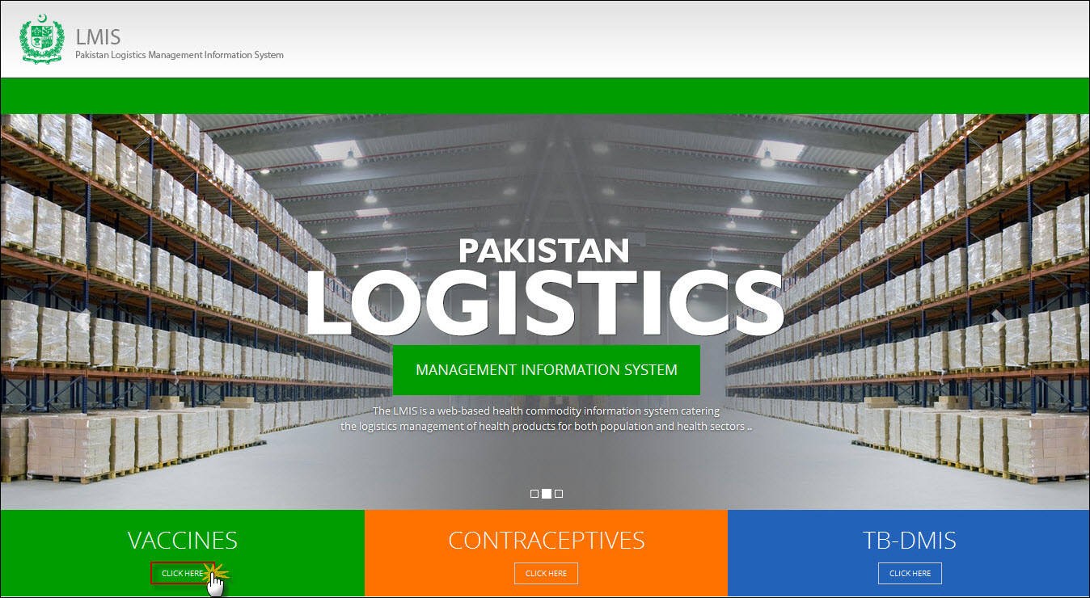**

Users can also access vaccine LMIS application directly by using <http://v.lmis.gov.pk> URL. Once the user enters the URL <http://v.lmis.gov.pk>, a user interface (homepage) will appear. The homepage displays a basic introduction to the ‘vaccine LMIS’.

|  |  |
| --- | --- |
| *C:\Users\isbah.zulfiqar\Desktop\1382615592_file_edit.png* | Before You Begin...  It is recommended to use vLMIS with Google or Mozilla Fire Fox. Older generations of browsers are also supported; however, their use can lead to issues with on-screen formatting and display. |

Once you click Vaccines, homepage for vLMIS will display.

## **Homepage Menu**

The available menu items can be found on the top of homepage screen. The components are displayed adjacently, as shown in the image below:

**C:\Users\Administrator\Desktop\vLMIS Screenshots\vaccine tab.jpg**

### **Contact Us Tab**

The Contact Us tab contains addresses, telephone numbers and email addresses (where available) for key personnel as a system communication list. Therefore, the user of LMIS will be able to see contact details of other stakeholders and can contact them as needed.

### **Frequently Asked Questions Tab**

The menu also contains a FAQ’s tab in order to provide guidance towards the most frequently asked and critical questions.

**Logging into Vaccine Logistics Management Information System**

vLMIS is a web-based inventory and cold chain management application that makes it simple for beginners and experienced users to report inventory and cold chain data, view performance and graphical reports as well as maps.

|  |  |
| --- | --- |
| *C:\Users\isbah.zulfiqar\Desktop\1382615592_file_edit.png* | **Before You Begin...**  Make sure you have your correct log in credentials. When you register with vLMIS, the accounts and its related details along with the login domain details will be provided to you by the vLMIS Administrator. |

To Log in to vLMIS:

1. Go to <http://v.lmis.gov.pk>
2. Click the button **Click Here** on the Vaccines tab. vLMIS login page will be displayed.

**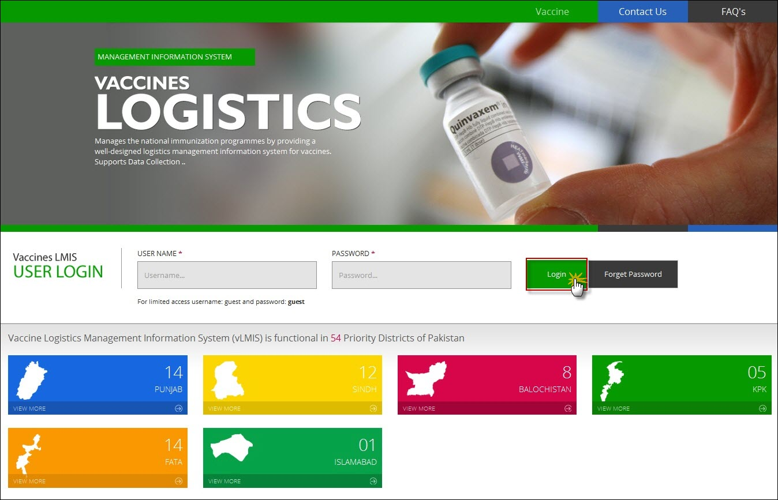**

1. Specify the **Username** and **Password** provided to you by the Administrator.

|  |  |
| --- | --- |
| *C:\Users\isbah.zulfiqar\Desktop\1382615592_file_edit.png* | To login as a guest or anonymous user, you can simply provide the following credentials:  **Username**: guest **Password**: guest |

|  |  |
| --- | --- |
|  | You can change the password provided to you by the administrator. See “*Changing Your Password*” for details.  Never give out your password to anyone for security purposes. |

1. Click **Login**.  
   The Vaccine Logistics Management Information System Dashboard Screen displays.

### **Changing Your Password**

To change your vLMIS password:

1. Login to vLMIS application.

The welcome screen displays.

1. On the right-side of the application, the user login name appears.
2. Under the login name, click Change Password as shown in the image below:

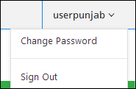

1. Specify the following:

* **Old Password**: specify your old password.
* **New Password**: specify the new password.
* **Confirm New Password**: retype your password.

|  |  |
| --- | --- |
| *C:\Users\isbah.zulfiqar\Desktop\1382615592_file_edit.png* | Password Requirements  Your password must have a combination of a capital alphabet and one Numeric. |

|  |  |
| --- | --- |
|  | Never give out your password to anyone for security purposes. |

1. Click **Change Password**.  
   Your password will be changed successfully.

### **Forgot Password**

In case you have forgotten your password:

1. Open the vLMIS login page by entering the URL: <http://v.lmis.gov.pk>.
2. In the Login section, click **Forgot Password** as shown in the image below:  
     
   **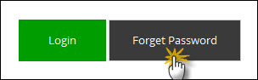**

You will be redirected to the Forgot Password Page.

1. In the Email entry box, enter your email address as validated in your account information by the Administrator.   
   An email will be sent on your email address for resetting your password.
2. Click the Reset Password link in the email to go to reset password page.
3. Specify the following:
   * **New Password**: specify the new password.
   * **Confirm New Password**: retype your password.

|  |  |
| --- | --- |
| *C:\Users\isbah.zulfiqar\Desktop\1382615592_file_edit.png* | Password Requirements  Your password must have a combination of a capital alphabet and one Numeric. |

|  |  |
| --- | --- |
|  | Never give out your password to anyone for security purposes. |

1. Click **Change Password**.  
   Your password will be changed successfully.

### **Logging Out**

When signed in, click **Sign out** on the right-side of the application, as shown in the image below:  
  


|  |  |
| --- | --- |
| Dashboards | **4** |
| in Vaccine Logistics Management Information System | |

This section explains the step-by-step instructions on the dashboard features that can be used by the Vaccine Logistics Management Information system’s users.

The Vaccine Logistics Management Information System enables you to login as an authenticated user to view different dashboards. These dashboards are available to different level users such as:

* National Level Dashboards
* Provincial Level Dashboards
* District Level Dashboards

# Overview

Dashboard is a visual display of the most important information needed to achieve one or more objectives; consolidated and arranged on a single screen so the information can be monitored at a glance.

## **Campaign User**

When a user logs in, s/he will view the campaign management dashboard as shown below:

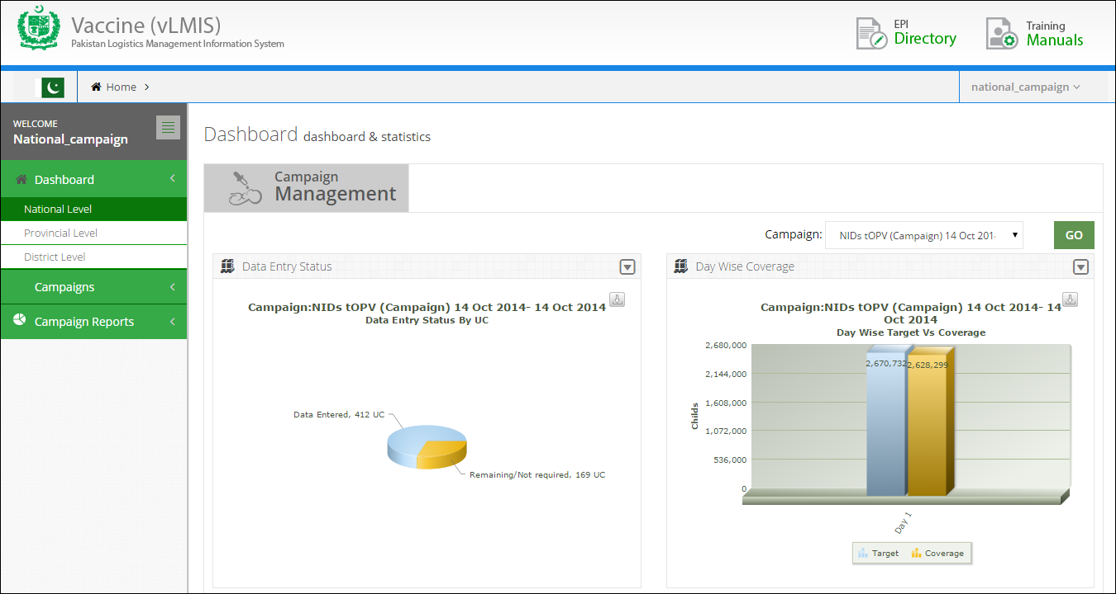

On the left-side of the screen, user can see the main menu with Dashboard tab. Users can select the level by clicking the Dashboard tab.

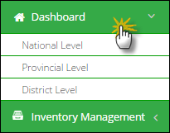

Select the National Level to view the Dashboard.

## **National Level Dashboard**

When national level user logs in, user will view the dashboard tabs as shown below:



### **Campaign Management**

Campaign Management dashboard allows users to view the campaign reports and graphs by clicking on this tab. It will show:

* **Campaign Data Entry Status**

Shows the data entry stats for a selected campaign in the pie chart.

* **Day wise Target vs Coverage**

Shows the day wise comparison of target versus coverage stats.

* **Missed Children Types**

This is the comparison graph of defined different missed as well as unreachable list.

* **Campaign vaccines (vials)**

To show the list of each campaign’s vaccines (vials) which are used in any or all districts in the specified time span.

Users can select the following filter:



* **Campaign:** select the desired campaign from the drop-down list.

Click **Go** to view campaign management dashboard graphs.

**Data Entry Status**

Campaign management dashboard shows the data entry status for each district in a pie chart. Users can view the reported (Data Entered) and non-reported (Remaining) districts in the chart.

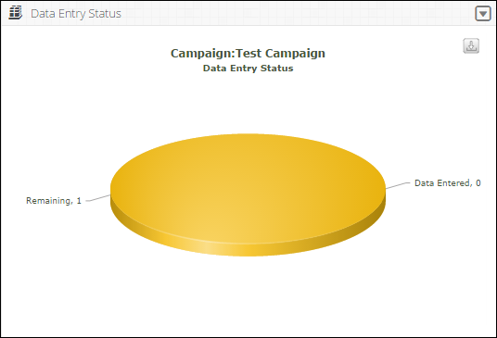

Users can also export charts in JPEG, PNG, PDF and SVG format.

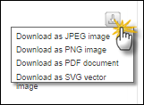

**Day Wise Target vs Coverage**

Campaign management dashboard also shows day wise target vs coverage for the selected campaign at the national level.

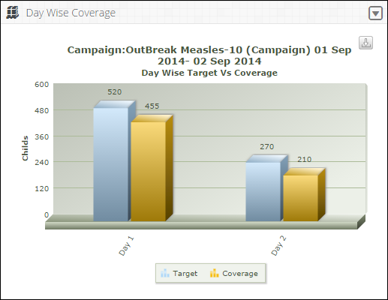

Click on **Target** or **Coverage** to view the target or coverage bar chart respectively.

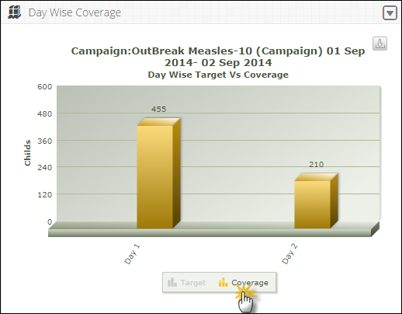

Users can also export charts in JPEG, PNG, PDF and SVG format.



**Missed Children Graph**

Campaign management dashboard also shows different type of the missed or unreachable children in a graphical manner.

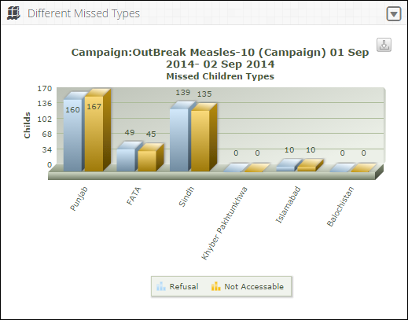

Click on **Refusal** or **Not Accessible** to view the refusal or not accessible children on the bar graph respectively.

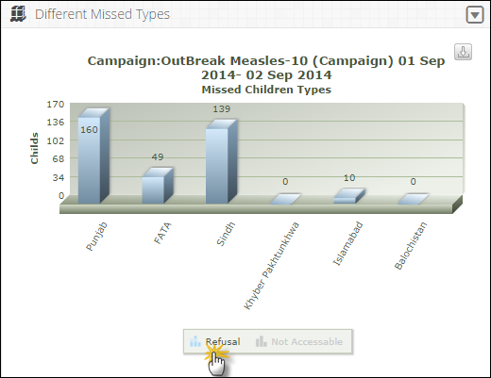

Users can also export charts in JPEG, PNG, PDF and SVG format.



**Campaign Vaccines**

Campaign management dashboard also shows the list of each campaign’s vaccines which are used in any or all districts in the specified time span.

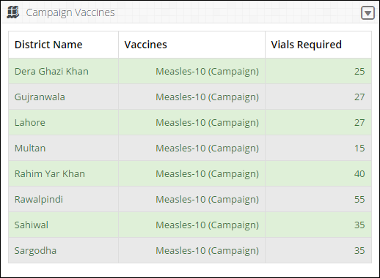

Users can also export charts in JPEG, PNG, PDF and SVG format.



Select the Provincial Level to view the desired Dashboard.

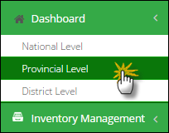

## **Provincial Level Dashboard**

When the user selects the provincial level, a dashboard screen will be displayed with four tabs.



User can select the Office and Province at the top of the dashboard screen. Province is selected by default at the provincial level dashboard. Select the Province and click **GO.**

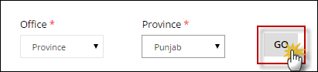

### **Campaign Management**

Campaign Management dashboard allows users to view the campaign reports and graphs by clicking on this tab. It will show:

* **Campaign Data Entry Status**

Shows the data entry stats for a selected campaign in the pie chart.

* **Day wise Target vs Coverage**

Shows the day wise comparison of target versus coverage stats.

* **Missed Children Types**

This is the comparison graph of defined different missed as well as unreachable list.

* **Campaign vaccines (vials)**

To show the list of each campaign’s vaccines (vials) which are used in any or all districts in the specified time span.

Users can select the following filter:



* **Campaign:** select the desired campaign from the drop-down list.

Click **Go** to view campaign management dashboard graphs.

**Data Entry Status**

Campaign management dashboard shows the data entry status for each district in a pie chart. Users can view the reported (Data Entered) and non-reported (Remaining) districts in the chart.



Users can also export charts in JPEG, PNG, PDF and SVG format.



**Day Wise Target vs Coverage**

Campaign management dashboard also shows day wise target vs coverage for the selected campaign at the national level.



Click on **Target** or **Coverage** to view the target or coverage bar chart respectively.



Users can also export charts in JPEG, PNG, PDF and SVG format.



**Missed Children Graph**

Campaign management dashboard also shows different type of the missed or unreachable children in a graphical manner.



Click on **Refusal** or **Not Accessible** to view the refusal or not accessible children on the bar graph respectively.



Users can also export charts in JPEG, PNG, PDF and SVG format.



**Campaign Vaccines**

Campaign management dashboard also shows the list of each campaign’s vaccines which are used in any or all districts in the specified time span.



Users can also export charts in JPEG, PNG, PDF and SVG format.



Select the District Level to view the desired Dashboard.

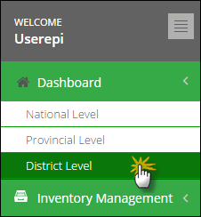

## **District Level Dashboard**

When the user selects the district level, a dashboard screen will be displayed with four tabs.



User can select the Office, Province at the top of the dashboard screen. Province and District is selected by default at the district level dashboard. Select the Province and the district and click **GO.**

**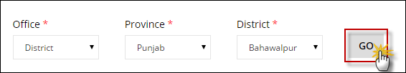**

### **Campaign Management**

Campaign Management dashboard allows district level users to view the campaign reports and graphs by clicking on this tab. It will show:

* **Campaign Data Entry Status pie chart**

Shows the data entry stats in the pie chart.

* **Day wise Target vs Coverage bar graph**

The day wise comparison of target versus coverage stats.

* **Missed Children Types bar graph**

This is the comparison graph of defined different missed as well as unreachable list.

* **Campaign vaccines (vials) required in Districts report**

To show the list of each campaign’s vaccines which are used in any or all districts in the specified time span.

Users can select the following filter:



* **Campaign:** select the desired campaign from the drop-down list.

Click **Go** to view campaign management dashboard graphs.

**Data Entry Status**

Campaign management dashboard shows the data entry status for each district in a pie chart. Users can view the reported (Data Entered) and non-reported (Remaining) districts in the chart.



Users can also export charts in JPEG, PNG, PDF and SVG format.



**Day Wise Target vs Coverage**

Campaign management dashboard also shows day wise target vs coverage for the selected campaign at the district level.

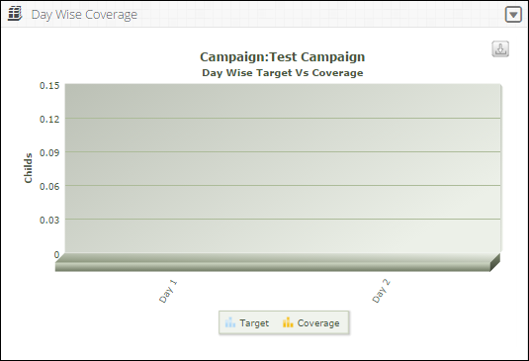

Users can also export charts in JPEG, PNG, PDF and SVG format.



**Missed Children Graph**

Campaign management dashboard also shows different type of the missed or unreachable children in a graphical manner.

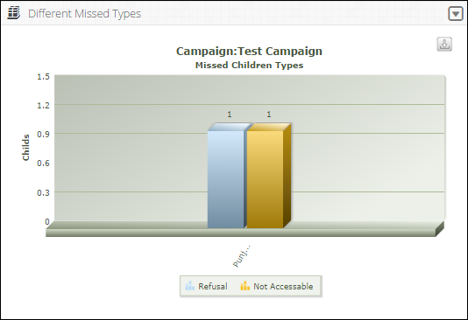

Users can also export charts in JPEG, PNG, PDF and SVG format.



**Campaign Vaccines**

Campaign management dashboard also shows the list of each campaign’s vaccines which are used in any or all UCs in the specified time span.

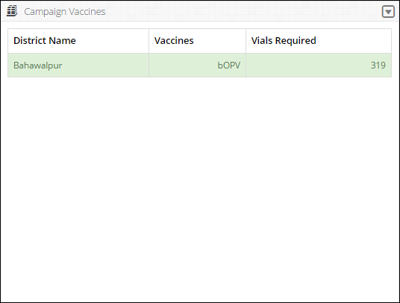

Users can also export charts in JPEG, PNG, PDF and SVG format.



|  |  |
| --- | --- |
| Campaigns | **5** |
| of Vaccines Logistics Management Information System | |

This section explains the overview of the Campaign User and describes the tasks to be performed using Vaccine Logistics Management Information System.

# Campaigns

Supplemental Immunization Activities (SIAs) commonly known as Campaigns against Poliomyelitis or Polio. In the early 20th century, polio was one of the most feared diseases in industrialized countries, paralyzing thousands of children every year. Soon after the introduction of effective vaccines in the 1950s and 1960s, however, polio was brought under control and practically eliminated as a public health problem in these developed countries.

Deriving strength from the experience gained in the developed countries, the World Health Assembly adopted a resolution in 1988, voicing firm resolve of the nations to eradicate polio from the globe through a world-wide Polio Eradication Initiative (PEI). Although the resolution was co-sponsored by Pakistan, PEI could not be launched in the country owing to scarcity of resources. However, PEI assumed top priority in public health in Pakistan in the aftermath of a massive outbreak of polio in 1993 which crippled thousands of children and resulted in the death of hundreds of them.

Since then, Supplemental Immunization Activities (SIAs) known as National Immunization Days (NIDs), Sub-national Immunization Days (SNIDs), Short Interval Additional Doses (SIADs), Outbreak Response and Mop-ups are being conducted in the light of the evolving epidemiologic situation in various parts of Pakistan. PEI has to continue till the goal of polio eradication is achieved and Pakistan joins the club of Polio Free Countries.

It is pertinent to mention that, at present, Pakistan is one of the three countries of the world which are polio-endemic. The other two countries are Afghanistan and Nigeria.

Vaccines are administrated to women and children in two type of Immunization Programs, Routine and Campaigns. The campaigns are different from routine Immunization. In routine people come to the health facility for immunization while in campaigns, temporary EPI teams, visit door to door and immunize the children to coupe any diseases outbreak. Normally in Pakistan, Polio (Poliomyelitis) and Measles Vaccines administration campaigns are present throughout the year.

## **Campaign Stock and Reporting Cycle**

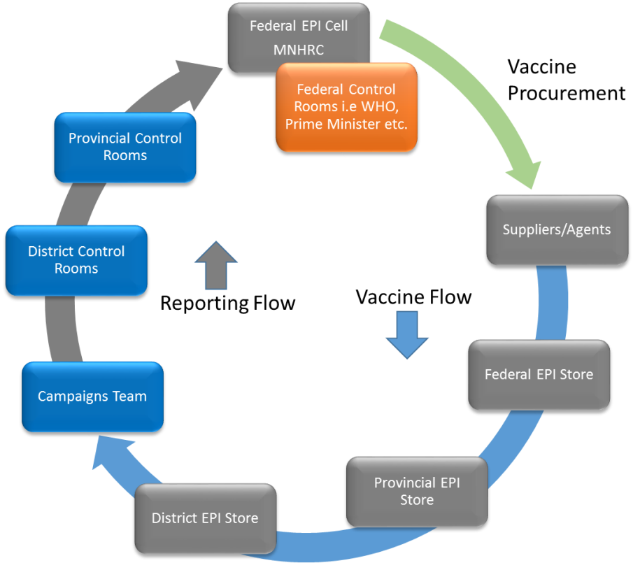In Current scenario, the Federal EPI cells arrange vaccine from supplier to supply vaccines to country vaccine supply chain i.e. from Federal EPI store to provincial to district EPI store, where it is provided to each Union Council (UC) Teams In-charge. Vaccines are supplier to teams through UC In-charge on daily basis. Team provided coverage reports to UC In-charge, who sends data to district control rooms, where data is entered into WHO made MS Access based software “SDMS”. A file from SDMS is exported and send to Provincial Control Rooms, where file is imported into SDMS provincial copy.

## **Campaign Enhancements**

In Release-1 of the application, campaigns figures were added on monthly aggregation basis such as routine immunization. However in Release-2, campaigns are introduced as separate module instead of enhancement in consumption reporting module. It is due to the users of campaigns module are different as compared to consumption module.

The scope of this module is limited to the following features in campaigns management:

* Addition of new campaigns, dates, vaccines and other attributes
* Setting up the population targets for each campaigns
* Manage Readiness of campaigns at UC and districts levels
* Data Entry at Districts Control rooms for Campaign days and Catch up days
* Monitoring tool Lot Quality Assurance Sampling (LQAS) data entry
* Monitoring reports at Federal, provincial and districts levels
* Data export for external analysis tools

# Campaign National User

Logging in to the National Campaign user account displays the account’s Home page screen with Campaign Management dashboard.

On the left side of the dashboard screen, the campaign user will see the following tabs:

**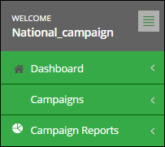**

User can sign out of the application by using the following link on the right side of the screen.

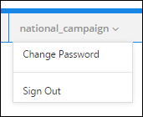

The national campaign user screen includes the following features:

* **Campaign Dashboard:** The homepage of National Campaign user shows campaigns dashboard at the national, provincial and district level.
* **Campaigns:** enables the user to manage the campaigns at the national level.
* **Campaign Reports:** enables the national user to view campaign reports.

## **Campaign Options**

Campaign decisions are made at National level and targets for each UC have been set by national users on the basis of population or last campaign consumption and un-covered children. A Campaign is for a single vaccine product, normally Polio (tOPV, mOPV3, bOPV) or Measles.

System provides a separate module for immunization campaigns all over the country. This module will contain data entry of each campaign.

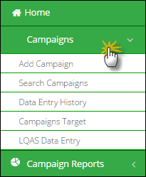

User can perform the following:

* **Add Campaign:** National users can add new campaigns in the system using this link.
* **Data Entry History:** National users can view the data entry history at district level by using this link.
* **Search Campaign:** National users can also search added campaigns by using this link.
* **Campaigns Target:** National users can search target for the added campaigns.
* **LQAS Data Entry:** National users can search LQAS data entry for UCs by using this link.

### **Add Campaign**

The Add New Campaign tab allow users to add a campaign by providing details such as type of campaign, targeted vaccines, level, dates and catch up days.

Users can select the following filters:

* **Campaign Type/SIA:** displays the list of types of campaigns.
* **Vaccine:** displays the list of vaccines according to the selected campaign type/SIA.
* **Name:** displays the name of the campaign. User can change this name according to his/her requirements.
* **Date From, Date To:** Click on Expiry date to expand the date picker tool, or type-in the required date using format dd/mm/yyyy.
* **Catch up days:** User can add catch up days after the campaign days as desired.
* **District:** Click District to check districts where a campaign is required to be conducted.

Click **Save** to add a new campaign. You can add different campaigns according to the targeted districts.

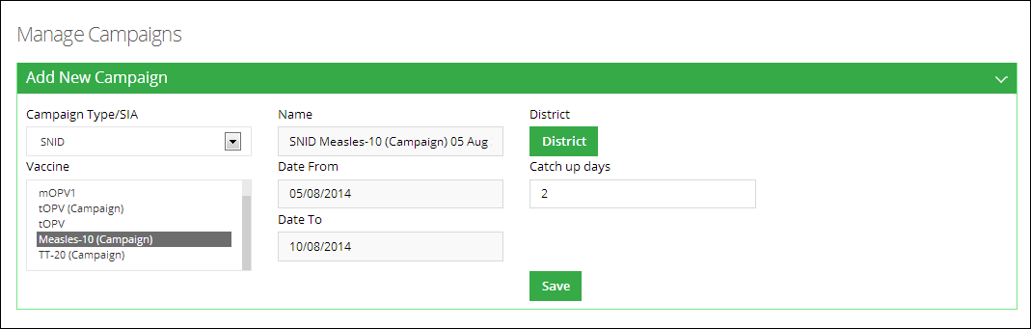

### **Data Entry History**

With the help of Data Entry History tab, the users can search the data entry history of different campaigns. By using search filters, the users can narrow down the data entry history for each day of the campaign.

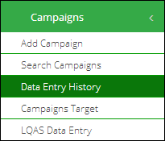

Users can select the following filters:

* **Campaigns:** displays the list of campaigns.
* **Province:** displays the list of provinces where the selected campaign is being conducted.
* **District:** displays the list of districts where the selected campaign is being conducted.
* **Product:** displays the product for which the campaign is being conducted.
* **Day:** Select one particular day from the list in which the campaign is being conducted.

Click **Search** to show the desired results as shown below. You can also search within the displayed records.

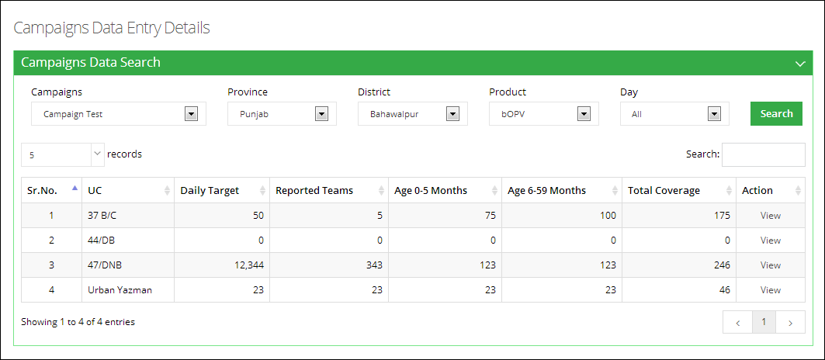

### **Search Campaigns**

By using Search Campaigns tab, the national users can search the added campaigns. By using filters, the users can narrow down the results. Users can also add and edit campaigns.

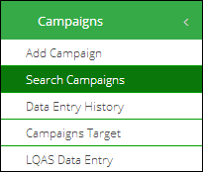

Users can select the following filters:

* **Campaign Name:** Add the name of the campaign you want to search.
* **Campaign Type:** displays the list of types of campaigns.
* **Vaccine:** displays the list of products for which campaign is being conducted.

Click **Search** to show the desired results as shown below.

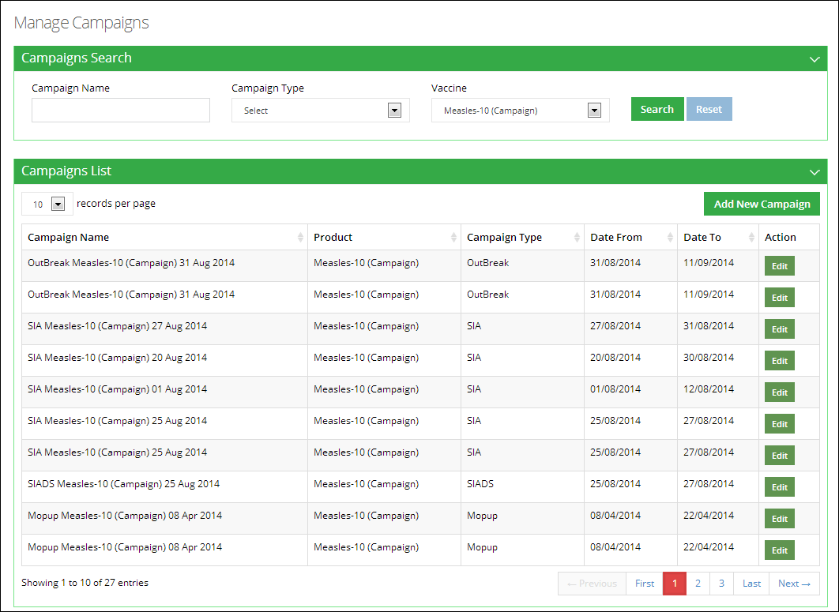

You can also add a new campaign directly from this option. Users are also provided with an option to edit the campaign to add updates. They can modify the target districts, dates, vaccine, catch up days and campaign type by using this option.

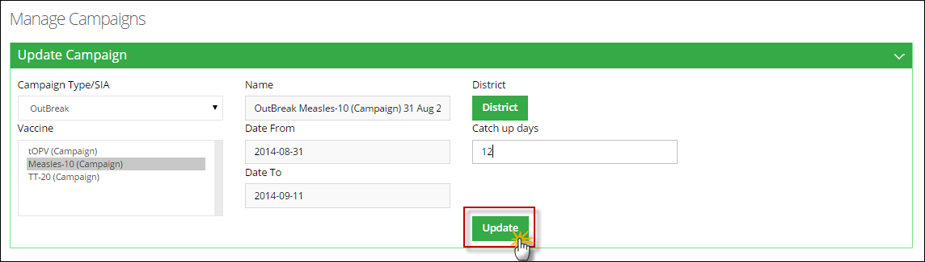

### **Campaigns Target**

Campaigns Target allows users to manage data of non-vaccinated children and coverage all over the defined region where the campaign will be held. The users can set the campaign target by three different methods:

* They can import CSV file containing campaign target data.
* Secondly, the users can import data from a previous campaign and,
* Lastly, the users can add/edit data manually.

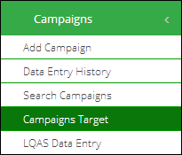

Users can select the following filters to search the campaigns:

* **Search Target For:** displays a list of campaigns.
* **Province:** displays the list of provinces where the selected campaign is being conducted.
* **District:** displays the list of districts where the selected campaign is being conducted.

Click **Search** to show the desired results as shown below.

**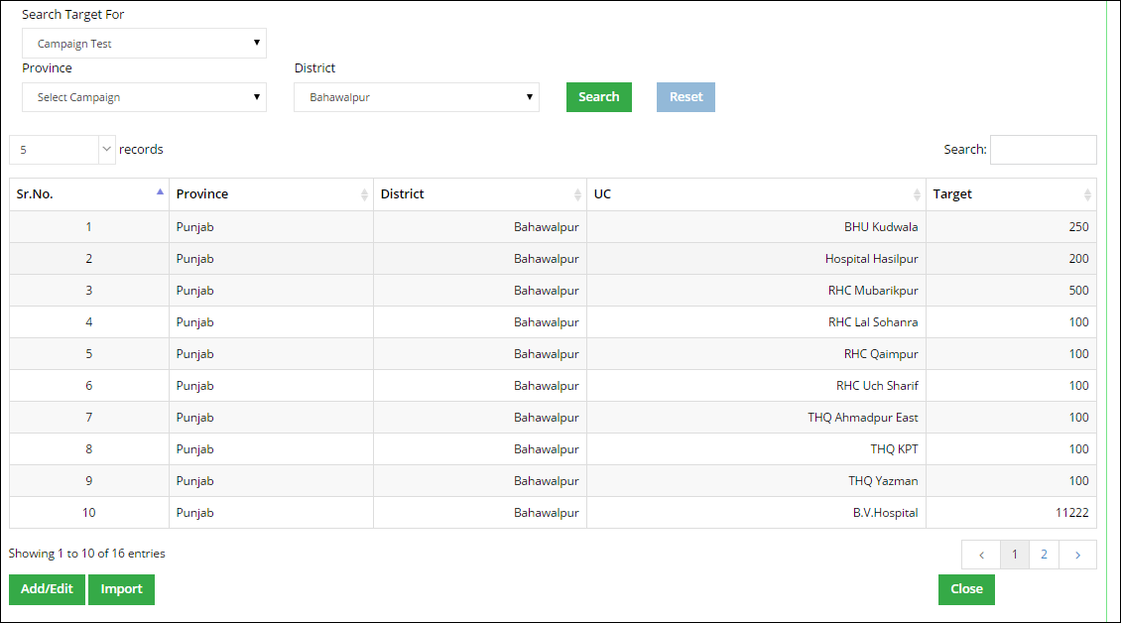**

User can also add/edit the campaign data as well as import data from CSV file or from a previous campaign.

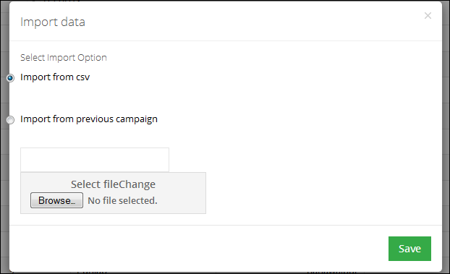

Click **Save.**

### **Lot Quality Assurance Sampling (LQAS) Data Entry**

The users can search Lot Quality Assurance Sampling (LQAS) data entries by using LQAS Data Entry Search tab.

Select the desired campaign from the **Campaign** tab and click **Search.**

A list of campaigns according to the UC level are displayed.

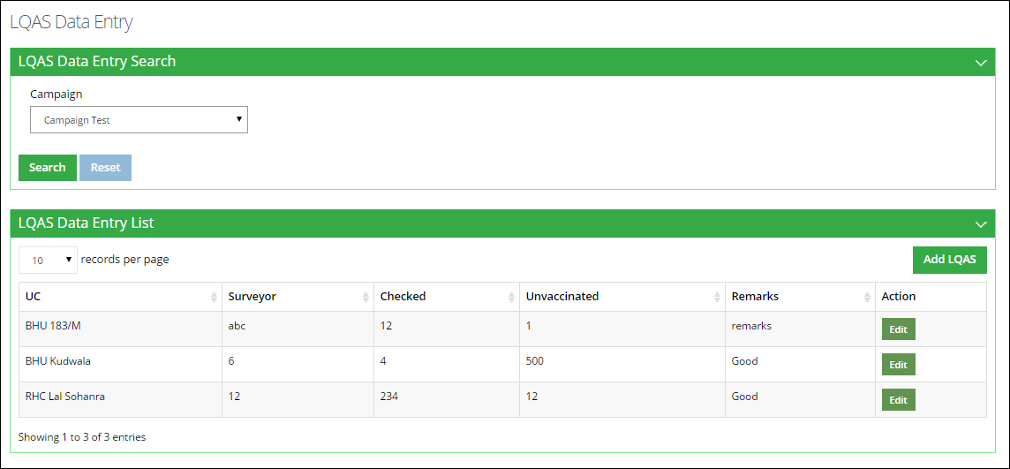

National users can add and edit LQAS data from here.

#### **Add LQAS**

Click **Add LQAS** on the screen. A new window will open.

Add the required information and click **Save.**

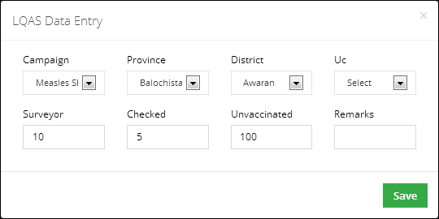

#### **Edit LQAS**

Click **Edit LQAS** on the screen. A new window will open.

Edit the required information and click **Update.**

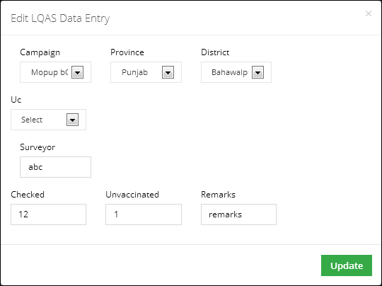

## **Campaign Reports**

National Users can also view the campaign reports from the Campaigns main-menu.

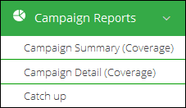

### **Campaigns Summary (Coverage)**

This report helps user to get list of all campaigns in a summary form. The list can be generated on all parameters required for adding a campaign.

Select **Province** and the **Year** for which you want to view report.

A list of districts for the selected province will be displayed along-with the analytical report for the data.

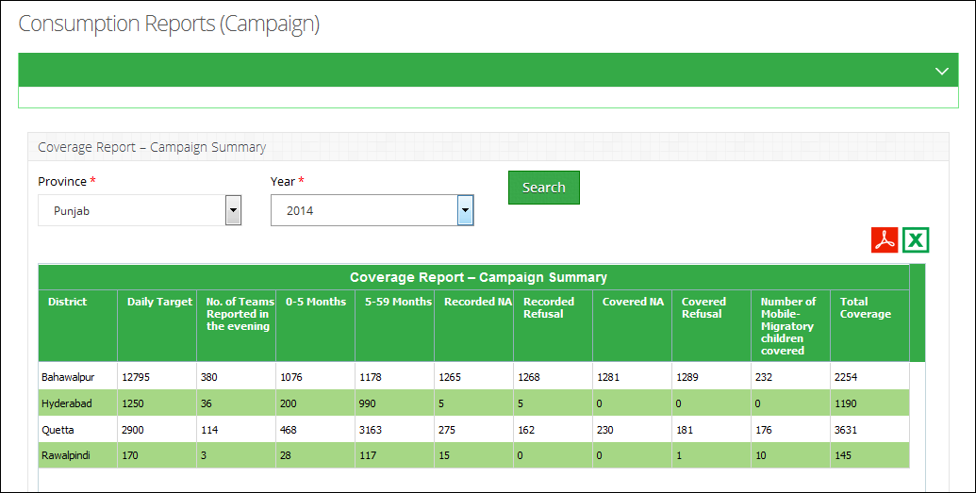

### **Campaigns Detail (Coverage)**

This report helps user to get list of all campaigns in detailed form. The list can be generated on all parameters required for adding a campaign.

Select **Province,** **District** and the **Campaigns** for with you want to view the report.

A list of tehsils for the selected district will be displayed along-with the analytical report for the data for each tehsil.

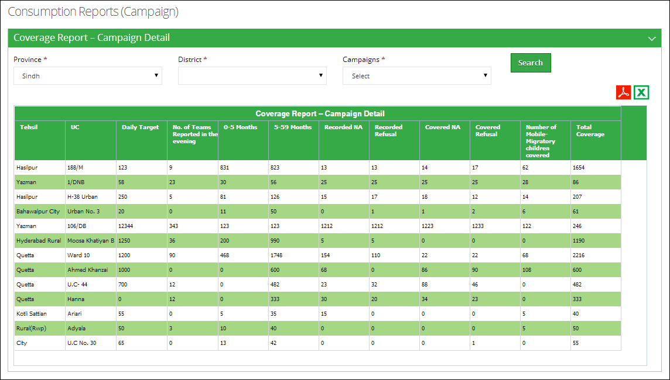

### **Catch-Up**

It is a monitoring report to find how much this campaign has been effective on the tehsil level.

Select **Province,** **District** and the **Campaigns** for with you want to view the report.

A list of tehsils for the selected district will be displayed along-with the analytical report for the data for each tehsil.

**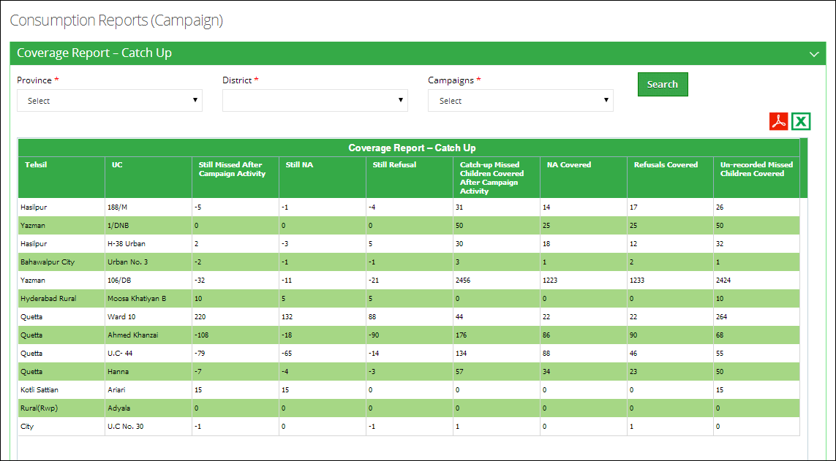**

# Campaign Provincial User

Logging in to the Provincial Campaign user account displays the account’s Home page screen with Campaign Management dashboard.

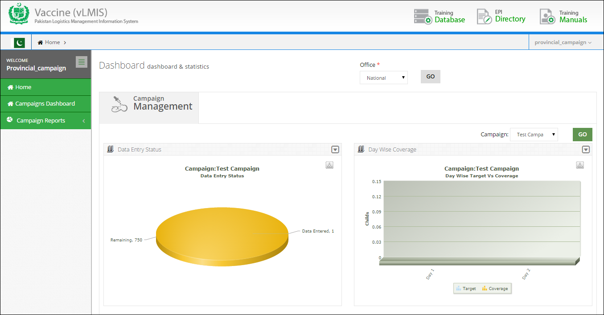

On the left side of the dashboard screen, the campaign user will see the following tabs:

**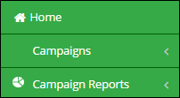**

User can sign out of the application by using the following link on the right side of the screen.

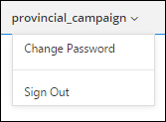

The provincial campaign user screen includes the following features:

* **Campaign Dashboard:** The homepage of Provincial Campaign user shows campaigns dashboard for the national, provincial and district level.
* **Campaigns:** enables the user to manage the campaigns at the provincial level.
* **Campaign Reports:** enables the provincial user to view campaign reports.

## **Campaign Options**

Campaign decisions are made at Provincial level as well and targets for each UC have been set by provincial users on the basis of population or last campaign consumption and un-covered children. A Campaign is for a single vaccine product, normally Polio (tOPV, mOPV3, bOPV) or Measles.

System provides a separate module for immunization campaigns all over the country. This module will contain data entry of each campaign.

User can perform the following:

* **Add Campaign:** Provincial users can add new campaigns in the system using this link.
* **Data Entry History:** Provincial users can view the data entry history at district level by using this link.
* **Search Campaign:** Provincial users can also search added campaigns by using this link.
* **Campaigns Target:** Provincial users can search target for the added campaigns.
* **LQAS Data Entry:** Provincial users can search LQAS data entry for UCs by using this link.

### **Add Campaign**

The Add New Campaign tab allow users to add a campaign by providing details such as type of campaign, targeted vaccines, level, dates and catch up days.

Users can select the following filters:

* **Campaign Type/SIA:** displays the list of types of campaigns.
* **Vaccine:** displays the list of vaccines according to the selected campaign type/SIA.
* **Name:** displays the name of the campaign. User can change this name according to his/her requirements.
* **Date From, Date To:** Click on Expiry date to expand the date picker tool, or type-in the required date using format dd/mm/yyyy.
* **Catch up days:** User can add catch up days after the campaign days as desired.
* **District:** Click District to check districts where a campaign is required to be conducted.

Click **Save** to add a new campaign. You can add different campaigns according to the targeted districts.



### **Data Entry History**

With the help of Data Entry History tab, the users can search the data entry history of different campaigns. By using search filters, the users can narrow down the data entry history for each day of the campaign.



Users can select the following filters:

* **Campaigns:** displays the list of campaigns.
* **Province:** displays the list of provinces where the selected campaign is being conducted.
* **District:** displays the list of districts where the selected campaign is being conducted.
* **Product:** displays the product for which the campaign is being conducted.
* **Day:** Select one particular day from the list in which the campaign is being conducted.

Click **Search** to show the desired results as shown below. You can also search within the displayed records.



### **Search Campaigns**

By using Search Campaigns tab, the national users can search the added campaigns. By using filters, the users can narrow down the results. Users can also add and edit campaigns.



Users can select the following filters:

* **Campaign Name:** Add the name of the campaign you want to search.
* **Campaign Type:** displays the list of types of campaigns.
* **Vaccine:** displays the list of products for which campaign is being conducted.

Click **Search** to show the desired results as shown below.



You can also add a new campaign directly from this option. Users are also provided with an option to edit the campaign to add updates. They can modify the target districts, dates, vaccine, catch up days and campaign type by using this option.



### **Campaigns Target**

Campaigns Target allows users to manage data of non-vaccinated children and coverage all over the defined region where the campaign will be held. The users can set the campaign target by three different methods:

* They can import CSV file containing campaign target data.
* Secondly, the users can import data from a previous campaign and,
* Lastly, the users can add/edit data manually.



Users can select the following filters to search the campaigns:

* **Search Target For:** displays a list of campaigns.
* **Province:** displays the list of provinces where the selected campaign is being conducted.
* **District:** displays the list of districts where the selected campaign is being conducted.

Click **Search** to show the desired results as shown below.

****

User can also add/edit the campaign data as well as import data from CSV file or from a previous campaign.



Click **Save.**

### **Lot Quality Assurance Sampling (LQAS) Data Entry**

The users can search Lot Quality Assurance Sampling (LQAS) data entries by using LQAS Data Entry Search tab.

Select the desired campaign from the **Campaign** tab and click **Search.**

A list of campaigns according to the UC level are displayed.



National users can add and edit LQAS data from here.

#### **Add LQAS**

Click **Add LQAS** on the screen. A new window will open.

Add the required information and click **Save.**



#### **Edit LQAS**

Click **Edit LQAS** on the screen. A new window will open.

Edit the required information and click **Update.**



## **Campaign Reports**

Provincial Users can also view the campaign reports from the Campaigns main-menu.



### **Campaigns Summary (Coverage)**

This report helps user to get list of all campaigns in a summary form. The list can be generated on all parameters required for adding a campaign.

Select **Province** and the **Year** for which you want to view report.

A list of districts for the selected province will be displayed along-with the analytical report for the data.



### **Campaigns Detail (Coverage)**

This report helps user to get list of all campaigns in detailed form. The list can be generated on all parameters required for adding a campaign.

Select **Province,** **District** and the **Campaigns** for with you want to view the report.

A list of tehsils for the selected district will be displayed along-with the analytical report for the data for each tehsil.



### **Catch-Up**

It is a monitoring report to find how much this campaign has been effective on the tehsil level.

Select **Province,** **District** and the **Campaigns** for with you want to view the report.

A list of tehsils for the selected district will be displayed along-with the analytical report for the data for each tehsil.

****

### **Lot Quality Assurance Sampling (LQAS) Report**

Lot Quality Assurance Sampling (LQAS) report is a monitoring report to find the effectiveness of a campaign.

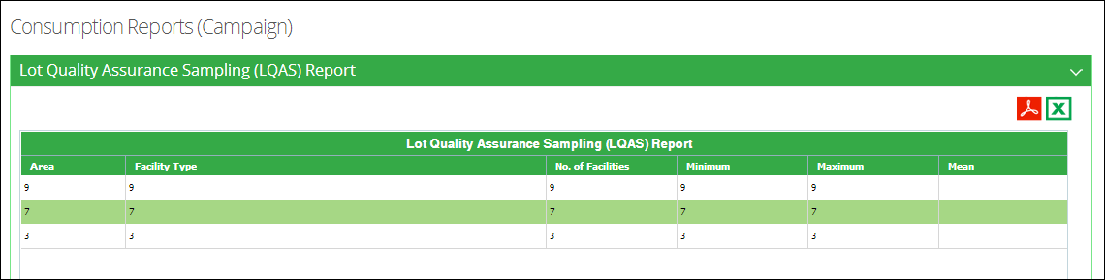

# Campaign District User

Logging in to the District Campaign user account displays the account’s Home page screen with Campaign Management dashboard.

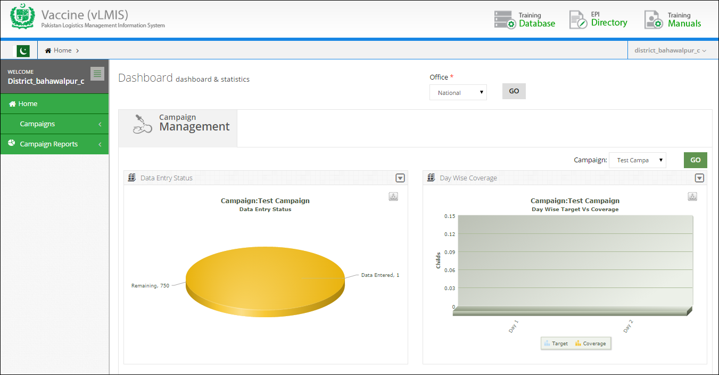

User can sign out of the application by using the following link on the right side of the screen.

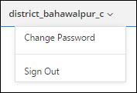

On the left side of the dashboard screen, the campaign user will see the following tabs:

**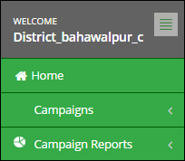**

The district campaign user screen includes the following features:

* **Campaign Dashboard:** The homepage of District Campaign user shows campaigns dashboard.
* **Campaigns:** enables the user to perform data entry for the campaigns at the district level.
* **Campaign Reports:** enables the provincial user to view campaign reports.

## **Campaign Options**

District Users can perform various activities regarding data entry and adding campaign readiness at district as well as UC level. System provides a separate module for immunization campaigns all over the country. This module will contain data entry of each campaign.

User can perform the following:

* **New Data Entry:** District users can perform data entry in the system using this link.
* **Data Entry History:** District users can view the data entry history at UC level by using this link.
* **Reported UCs:** District users can view a list of reported UCs and reporting rate by using this link.
* **Campaign Readiness:** District users can view, add and edit campaign readiness for each district by using this link.
* **Campaign Readiness UC:** District users can view, add and edit campaign readiness for each UC by using this link.

### **New Data Entry**

District users can add campaign data for each UC based on the number of campaign days.

Click **Campaigns** from the main menu and select **New Data Entry.**

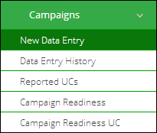

New Data Entry screen displays. Enter data in the required fields**.**

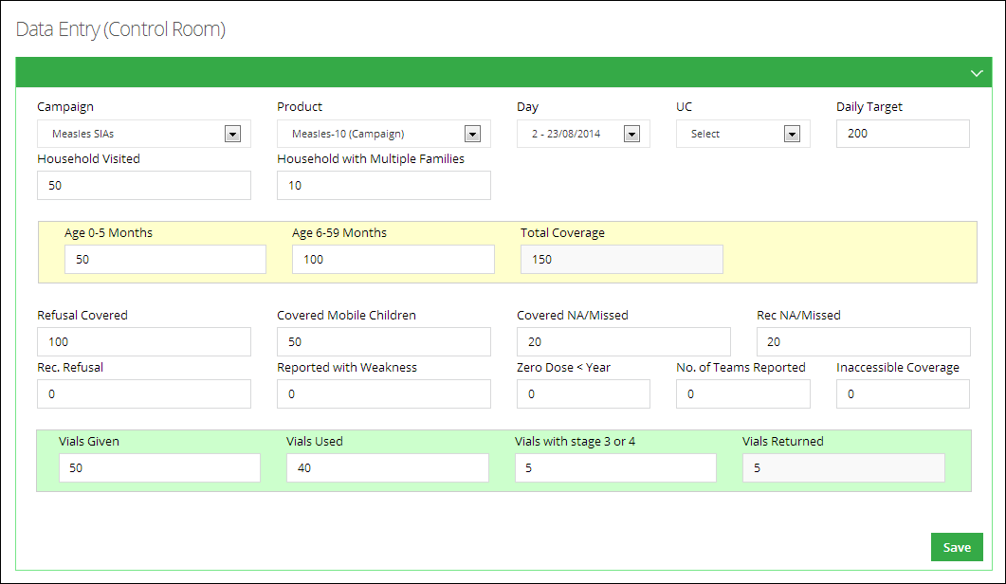

Click **Save** to save the added data.

### **Data Entry History**

With the help of Data Entry History tab, the users can search the data entry history of different campaigns. By using search filters, the users can narrow down the data entry history for each day of the campaign.

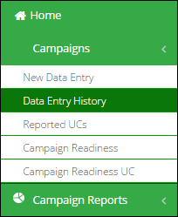

Users can select the following filters:

* **Campaigns:** displays the list of campaigns.
* **Province:** displays the list of provinces where the selected campaign is being conducted.
* **District:** displays the list of districts where the selected campaign is being conducted.
* **Product:** displays the product for which the campaign is being conducted.
* **Day:** Select one particular day from the list in which the campaign is being conducted.

Click **Search** to show the desired results as shown below. You can also search within the displayed records.



### **Campaign Readiness**

By using Campaign Readiness Search, the users can search the targeted campaign from the list of campaigns. District user can enter the status of different indicators of a campaign at District level. By using these indicators, the National user will make decision on the readiness of a campaign.

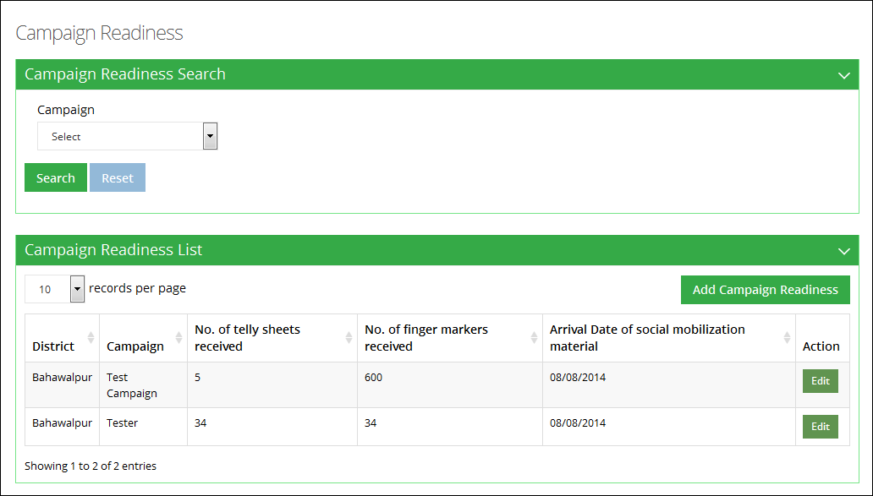

#### **Edit Campaign Readiness**

By using Edit Campaign Readiness, the users can edit/update campaign readiness data, e.g. the vaccine, required vials, number of tally sheets received, number of finger markers received.

Edit the required information and click **Update.**

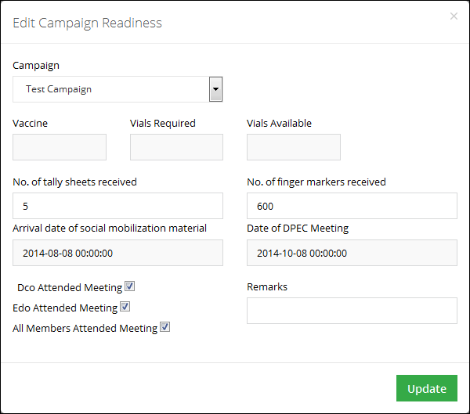

#### **Add Campaign Readiness**

With the help of Add Campaign Readiness tab, the user can enter the status of different indicators of a campaign at District level.

Add the required details and click **Save.**

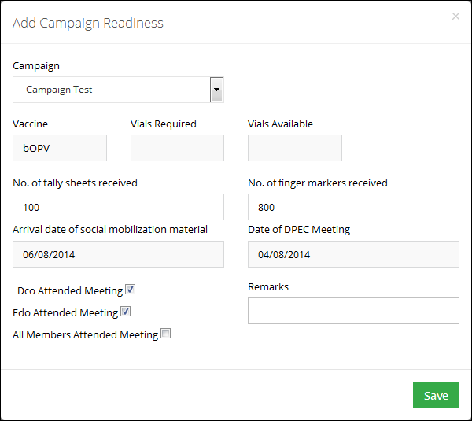

### **Campaign Readiness UC**

The District users can enter readiness of campaign data at UC level by using Campaign Readiness UC tab. By using Campaign Readiness UC Search, the users can search the targeted campaign from the list of campaigns by selecting the campaign and the required UC. By using these indicators, the National user will make decision on the readiness of a campaign.

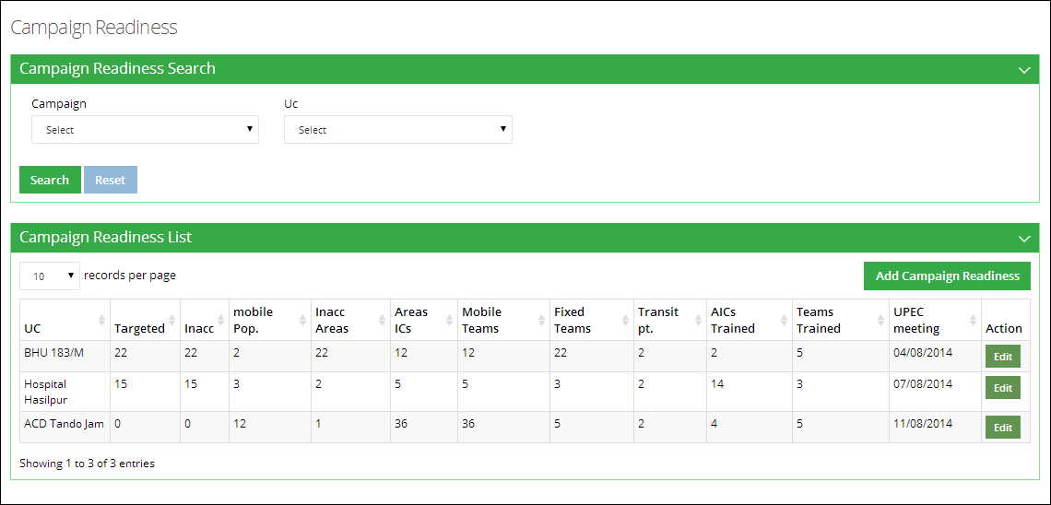

#### **Edit Campaign Readiness**

By using Edit Campaign Readiness, the users can edit/update campaign readiness data, e.g. the vaccine, required vials, number of tally sheets received, number of finger markers received.

Edit the required information and click **Update.**

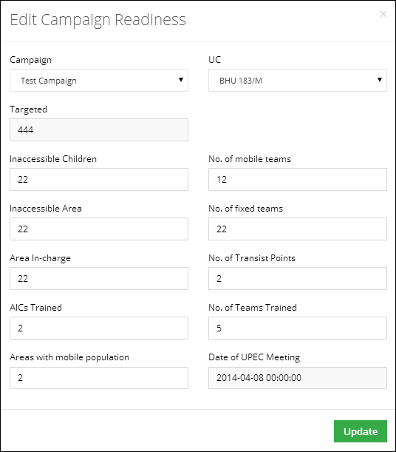

#### **Add Campaign Readiness**

With the help of Add Campaign Readiness tab, the user can enter the status of different indicators of a campaign at District level.

Add the required information and click **Save.**

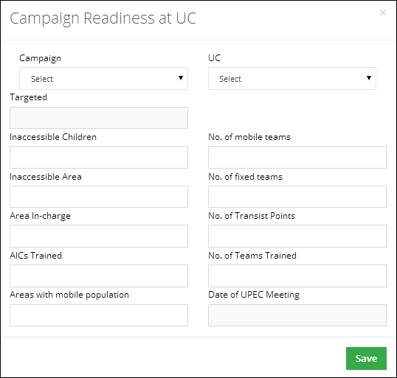

### **Reported UCs**

The users need to report per day consumption of particular campaign in a district and the reporting status of these districts can be viewed in Reported UCs tab.

Select the campaign and click **Search.**

Reported UCs for the selected campaign will be displayed in the list along-with the reporting status.

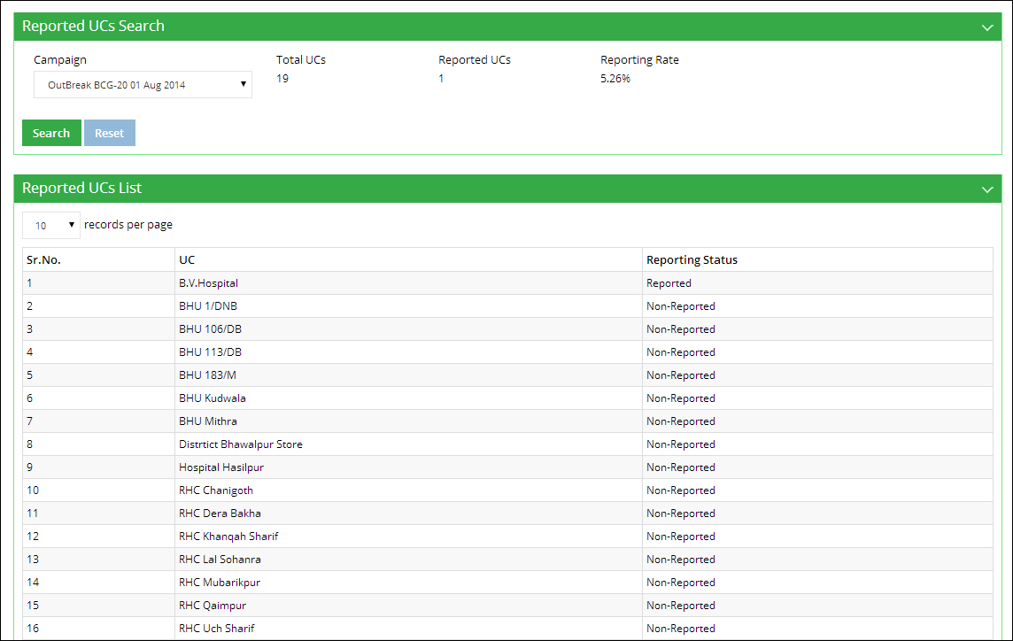

## **Campaign Reports**

Users can also view the campaign reports from the Campaigns main-menu.



### **Campaigns Summary (Coverage)**

This report helps user to get list of all campaigns in a summary form. The list can be generated on all parameters required for adding a campaign.

Select **Province** and the **Year** for which you want to view report.

A list of districts for the selected province will be displayed along-with the analytical report for the data.



### **Campaigns Detail (Coverage)**

This report helps user to get list of all campaigns in detailed form. The list can be generated on all parameters required for adding a campaign.

Select **Province,** **District** and the **Campaigns** for with you want to view the report.

A list of tehsils for the selected district will be displayed along-with the analytical report for the data for each tehsil.



### **Catch-Up**

It is a monitoring report to find how much this campaign has been effective on the tehsil level.

Select **Province,** **District** and the **Campaigns** for with you want to view the report.

A list of tehsils for the selected district will be displayed along-with the analytical report for the data for each tehsil.

****

